**Resource Writeup: Joke API**

The Joke API provides access to 1369 jokes from 6 different languages. It has a few filters that can be applied to get the type of jokes that one would like. It’s a REST API and doesn’t require ay API token, membership, or registration. When accessed, it returns JSON formatted values including the joke itself, category of the joke, any flags for the joke, and the language it is in.

**How to Access Jokes**

When generating URL, you can pass in parameters by formatting it a certain way. Parameters need to be prefixed by a single question mark (?) and its key/value pair need to be delimited from another by an ampersand (&). Keys are separated from values with an equals sign (=). For example, <https://example.org/some/page?key1=foo&key2=bar&key3=baz>

The format parameter (?format=format) tells the API which format it should serve the joke in. If the value passed is invalid or if not passed at all, the default value of JSON will be used.

The joke type parameter (?type=type) is used when you want to only receive jokes with specified joke types. There are two types: single and two-part.

The contains parameter (?contains=string) lets you search for a keyword, returning a joke that contains the string passed as the parameter.

The joke amount parameter (?amount=number) lets you decide the number of jokes you will get. If multiple, you will get separate dictionaries returned to you for each joke.

Although not specified as a parameter, you can include the joke categories that you want to pull jokes from in the URL. The categories come right after the base URL, which is <https://v2.jokeapi.dev/joke/>. At the end of this URL, you can add categories like programming, misc, dark, pun, separated by commas. For example, if you wanted programming jokes and dark jokes, you would build a URL that looks like this: <https://v2.jokeapi.dev/joke/Programming,Dark>

The result would be:

{  
 "error": false,  
 "category": "Programming",  
 "type": "single",  
 "joke": "Java is like Alzheimer's, it starts off slow, but eventually, your memory is gone.",  
 "flags": {  
 "nsfw": false,  
 "religious": false,  
 "political": false,  
 "racist": false,  
 "sexist": false,  
 "explicit": false  
 },  
 "id": 27,  
 "safe": false,  
 "lang": "en"  
}

**Example Apps**Dark1

This app uses the Joke API to fetch only its dark jokes, providing them on a mobile client.

Dozens Advices

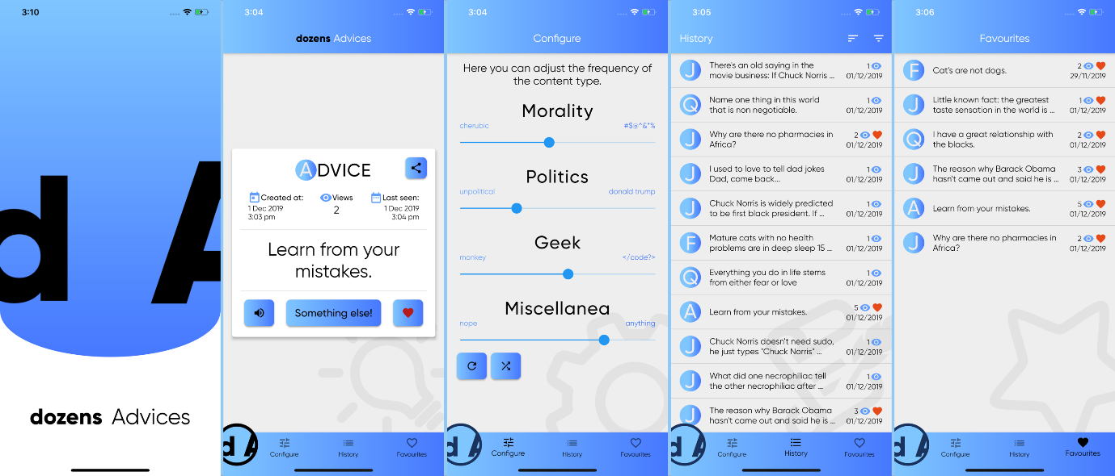

This is a flutter app that is an aggregator of jokes, advices, quotes and facts. It provides filters for users so that they can, for example, configure the application to receive black humor and jokes about programming, while excluding content related to politics.

**Resources**

<https://sv443.net/jokeapi/v2/>